LUMEN™ EASE Customer Impact Bulletin

Date of Notification: February 4, 2021
Subject: EASE LSR system updates
System(s) Impacted: EASE LSR
Areas Impacted: All EASE customers
Date Effective: 02/04/2021

This notice is to provide customer visibility to updates that will become effective in the EASE-LSR ordering platform.
PON Naming Convention:
Customers using the EASE-LSR ordering platform will now be able to place a HYPHEN (-) in the pon name. This modification will be supported for customers using EASE-LSR for the traditional CenturyLINK (LC) territories as well as customers that have migrated from the IMA platform for the traditional Qwest (LQ) regions.

EASE-LSR VFO Market Identification:
Customers will notice the Market Identification associated to the PONs updated on the EASE VFO Home page. This will be determine based on the ESP value selected during order initiation. Customers will see the values:
- LC – Traditional CenturyLink operating territories (ESP values containing 4 characters)
- LQ – Traditional Qwest Operating territories (ESP values containing 3 characters)

Customers will also have the option to filter PON results by operating territory on the EASE Home Screen by checking the appropriate selection.
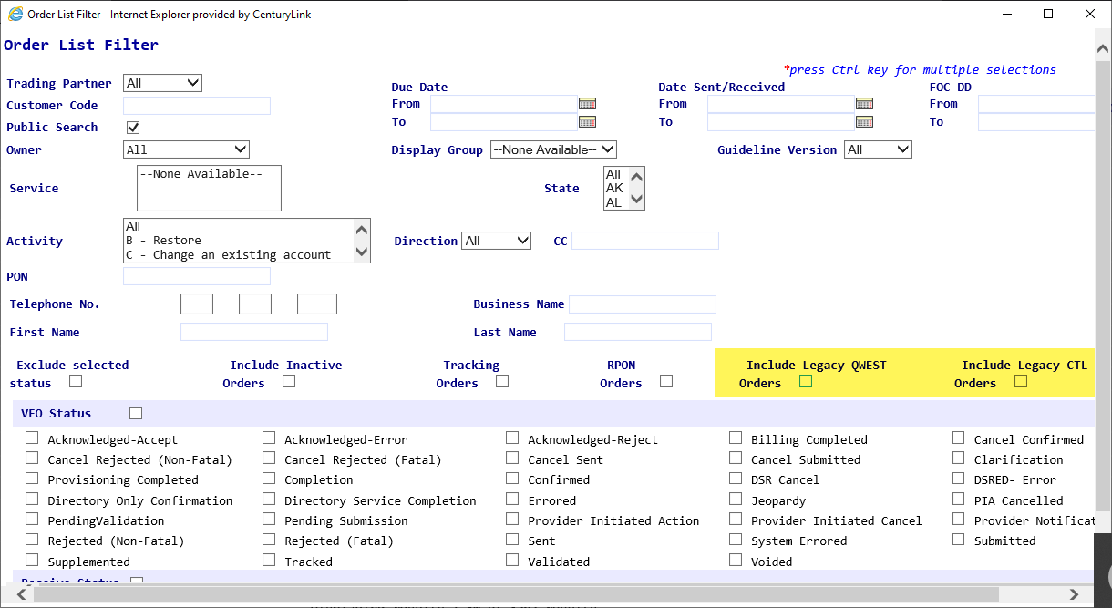

EXTERNAL APP cleanup effective February 19th, 2021

EASE LSR VFO GUI users will see the following modifications:

EASE LSR VFO Home Page:
The following highlighted options will be removed from the External App Data visible from the EASE-LSR VFO Home page:
- TN Assignment (currently available thru PREORDER)
- Available Services (currently available thru PREORDER)
- Available Pics (available from within the ORDER only)
- Existing Service (currently available thru PREORDER)
- View Directory Name (available from within the ORDER only)

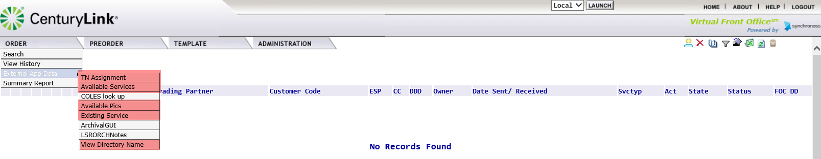

EASE LSR VFO Order Page:
The following options will be removed from the External App Data visible from the EASE-LSR VFO Home page
- COLES look up (available from the EASE-LSR VFO GUI Home page only)

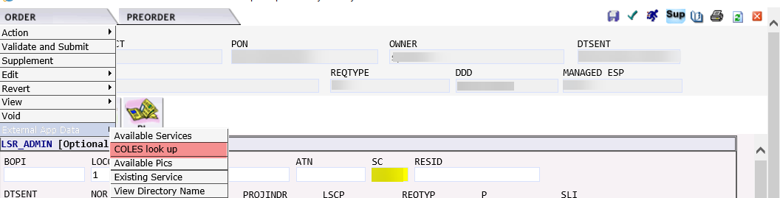

Any questions regarding this change can be directed to Letty.Walker@Lumen.com.

